Pandas school analysis

1. Based on the below table of school spending Vs student performance we can see that school with less budget per student have higher overall passing %.

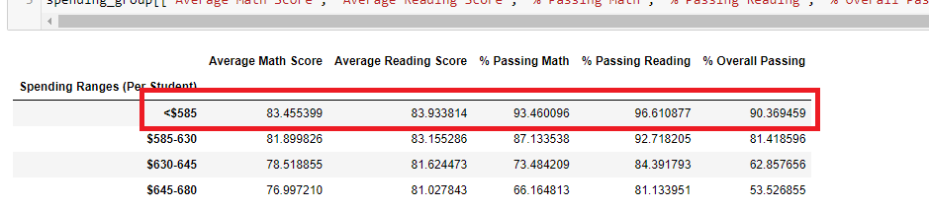

1. Based on scores by school type, charter school have much better overall passing rate then district school.

